Unit 7- Vector Word Problem WS
1) Two ropes are tied to a wagon. A child pulls one with force of 20 pounds, while another child pulls the other with a force of 30 pounds. If the angle between the two ropes is 28°, how much force must be exerted by a third child, standing behind the wagon, to keep the wagon from moving? (Hint: Assume the wagon is at the origin and one rope runs along the positive x-axis. The third child must use the same amount in the opposite direction.)
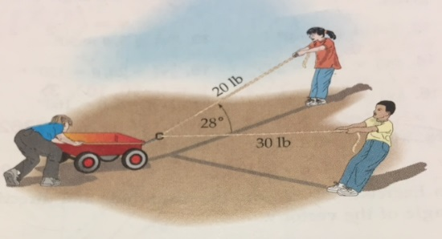

2) Two circus elephants, Bessie and Maybelle, are dragging a large wagon. If Bessie pulls with a force of 2200 pounds and Maybelle with a force of 1500 pounds and the wagon moves along the dashed line, what is angle $θ$?
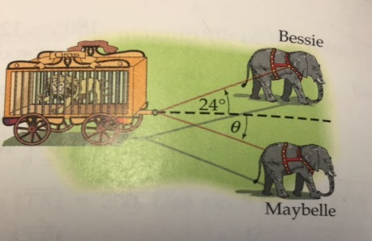
For #3, find the course and ground speed of the plane under the given conditions. All angle measurements are given as aerial navigation directions.
3) air speed 250 miles per hour in the direction of 60°; wind speed 40 miles per hour from the direction 330°
4) A plane if flying in the direction 200° with an air speed of 500 miles per hour. Its course and ground speed are 210° and 450 miles° per hour, respectively. What is the direction and speed of the wind?
5) A river flows from east to west. A swimmer on the south bank wants to swim to a point on the opposite shore directly north of her starting point. She can swim at 2.8 miles per hour, and there is a 1- mile-per-hour current in the river. In what direction should she swim in order to travel directly north (that is, what angle should the swimmer make with south bank of the river)?
6) A river flows from west to east. A swimmer on the north bank swims 3.1 miles per hour along a line that makes a 75° angle with the north bank of the river and reaches the south bank at a point directly south of his starting point. How fast is the current in the river?

